Paul Collado
CSC-208
Lab01 Page 58
Auto Center
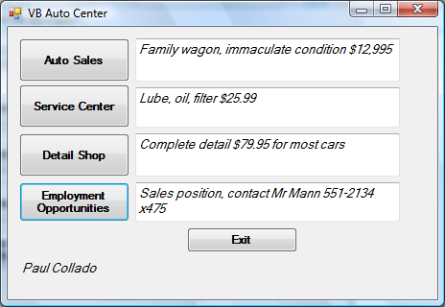
Public Class frmColladoCh01Page58

Private Sub btnAutoSales_Click(ByVal sender As System.Object, ByVal e As System.EventArgs) Handles btnAutoSales.Click
'Display Auto Sales
Me.txtAuto.Text = "Family wagon, immaculate condition $12,995"

End Sub

Private Sub btnService_Click(ByVal sender As System.Object, ByVal e As System.EventArgs) Handles btnService.Click
'Display Service Center
Me.txtService.Text = "Lube, oil, filter $25.99"

End Sub

Private Sub btnShop_Click(ByVal sender As System.Object, ByVal e As System.EventArgs) Handles btnShop.Click
'Display Detail Shop
Me.txtShop.Text = "Complete detail $79.95 for most cars"

End Sub

Private Sub btnEmployment_Click(ByVal sender As System.Object, ByVal e As System.EventArgs) Handles btnEmployment.Click
'Display Employment Opportunities
Me.txtEmployment.Text = "Sales position, contact Mr Mann 551-2134 x475"
End Sub

Private Sub btnExit_Click(ByVal sender As System.Object, ByVal e As System.EventArgs) Handles btnExit.Click
'Closes program
Me.Close()

End Sub
End Class

